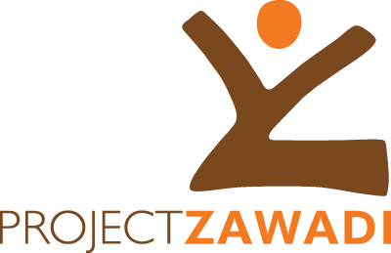  ENGLISH BRIDGE PROGRAM  Employment Opportunity  Position: English Teacher  Report to: Director of Tenda Teachers in Nyamuswa, Bunda, Mara (5 positions available) | Partnering with Communities, Schools, and Teachers to Support Quality Education for Tanzanian Children and Youth
Job Summary
The English Bridge program is a seven-week intensive course aimed at Standard 7 graduates to be held at several local schools with English teachers leading conversation and comprehension lessons designed to prepare students to better face the English language challenges they will meet in Form 1, giving them a leg-up for success in secondary school.
Job Description
Purpose: To teach and educate students in the oral and written use of English such that students are prepared to grasp Form 1 content.
Main Responsibilities
- Plan, prepare and deliver lessons according to the English Bridge Curriculum and aligned with the English Bridge approach
- Establish and maintain a class decorum that is conducive to learning for all students
- Provide honest and transparent feedback to the EB Director and the Teacher Team, both positive and negative, on students, curriculum and approach
- Manage materials and supplies provided by EB
- Direct and supervise volunteers
- Manage the working relationship with Head Teachers at the schools
- Address specific student needs as required
Requirements
- A qualified graduate from an accredited Tanzanian teacher’s college or university
- Fluent both in written and spoken English
- Teaching Experience at international schools is an added advantage
- Open to new ideas and teaching methods
- Willingness to learn, be challenged and show initiative
- Punctuality and openness
- Available to be in Nyamuswa, Bunda, Mara from Oct 30 to Dec 20, 2019
Mode of work: Part time – 6 hours 5 days a week
Salary and other benefits: Food, housing and stipend provided.
Application Deadline: September 20th 2019
Send your CV and a cover letter to The Director of Tenda Teachers via email adrian@projectzawadi.org
Please visit https://www.projectzawadi.org for more information on Project Zawadi.
Nb: only shortlisted candidates will be contacted

